**Lesson 6.1 Comparing Data Displayed in Dot Plots**

A dot plotis a visual way to show the spread of data. A number line is used to show every data point in a set. When the data are symmetric about the center, and the median has the greatest number of data, then the shape is described as a normaldistribution. Recall that symmetric means that the two halves are mirror images. In a data set with normal distribution, the mean, median, and mode are equal.

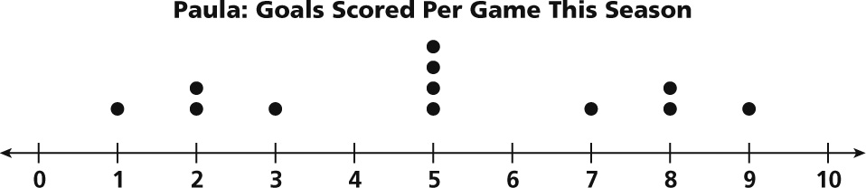

This dot plot shows a normaldistribution.

• The data are symmetric about the center, 5.

• The median has the greatest number of data.

• The mean, median, and mode are all 5.

Data sets do not always have normal distribution. The data may cluster more to the left or right of center. This is called a skewed distribution. The measures of center for a skewed data set with skewed distribution are not all equal.

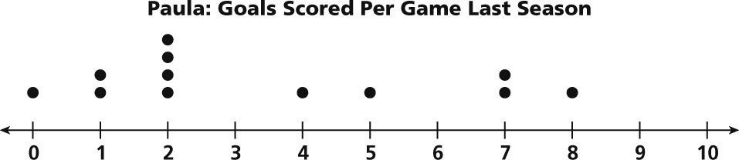

This dot plot shows a *skewed* distribution.

• The data are not symmetric.

• The mean, median, and mode vary.

• The data are skewed to the left.

Which Measure of Central Tendency?

**Mean**- is the average of the data- it is useful for describing data that are close in value and data that are normally distributed. It is not useful when there are OUTLIERS, which can skew the mean to the right or left of the data.

**Median-** is the middle value- it is useful when data is NOT normally distributed or that has outliers.

**Mode-** is the number that occurs the most – it is useful when data clusters around certain values. It is the only measure of the three that can be used to describe non-numerical, categorical data.

EXAMPLES:

Describe the shape of the data distribution for the dot plot.

1. 